**Insights of Facial Recognition Bias Detection using ACE**

**1. Documenting Clusters Corresponding to Meaningful Concepts**

The TCAV scores in this analysis reveal clusters corresponding to specific visual characteristics. For the `mixed4c` layer, the ACE analysis has identified clusters that are heavily influenced by distinct visual features.

Below are the TCAV scores and their associated concepts:

**Concept 14: Darker Shade Hair**

TCAV Scores:

- Score 1: 0.5867

- Score 2: 0.5799

This cluster captures darker hair shades, which have a strong influence on the model’s decision-making. The high TCAV score indicates that the model associates dark hair with the target class.

**Concept 1: Darker Shade Hair**

TCAV Scores:

- Score 1: 0.5829

- Score 2: 0.3683

Like Concept 14, this cluster also relates to dark hair shades. The relatively high TCAV score, and moderate variance suggest a significant but slightly less consistent influence on the model's predictions.

**Concept 20: Background with Light Shades**

TCAV Scores:

- Score 1: 0.5752

- Score 2: 0.4260

Concept 20 represents light backgrounds, often close to white. The high TCAV score indicates that the model is sensitive to background features, which could be a sign of contextual bias.

**Concept 5: Brown Shade Skin (Shadows)**

TCAV Scores:

- Score 1: 0.5714

- Score 2: 0.3222

This concept captures brown-shaded skin areas, often seen in shadows. Its relatively high TCAV score highlights the influence of lighting, particularly the shadows cast on the skin, in the model’s decision-making.

**Other Concepts: Skin Tone and Light Background**

Examples of TCAV Scores:

- Concept 3: 0.5705, 0.1299

- Concept 6: 0.5400, 0.0171

- Concept 9: 0.5410, 0.0300

These concepts generally represent lighter skin tones or backgrounds. They show less influence compared to the darker shades and backgrounds, as reflected in their lower TCAV scores.

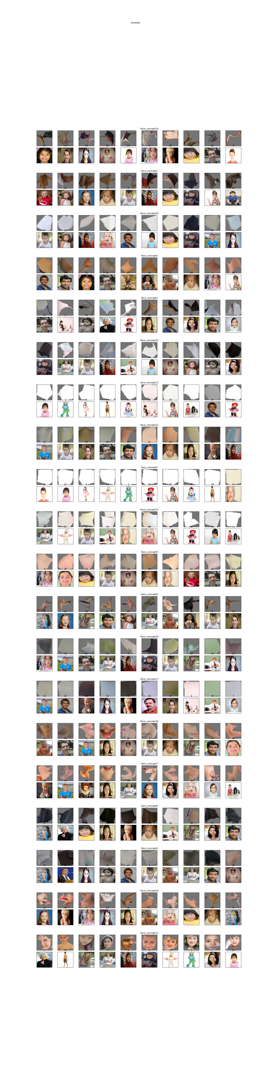





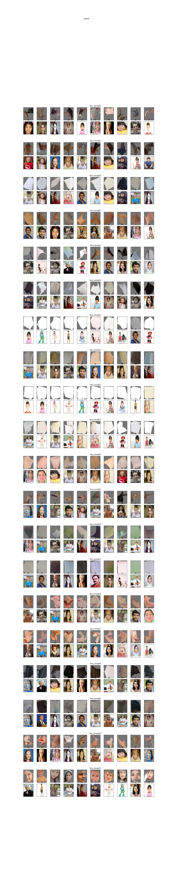

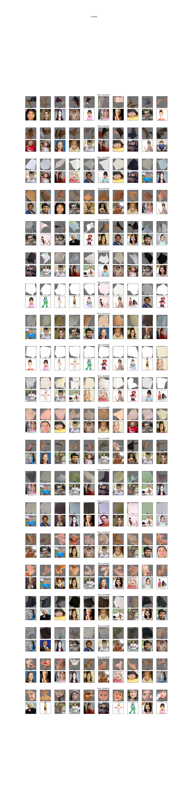

Fig 1: Visualizations of mentioned Concepts.

**2. Model Sensitivity and Indication of Potential Bias**

The model’s sensitivity to the identified concepts suggests several potential biases:

**Hair Color Sensitivity**: The high TCAV scores for Concepts 14 and 1, associated with darker hair, imply that the model heavily relies on hair color in its predictions. This focus on hair shade may result in a bias towards individuals with darker hair, underperforming for individuals with lighter hair or without prominent dark hair features.

**Background Influence:** Concept 20, representing light backgrounds, shows the model’s high sensitivity to background features. This suggests that the model is placing importance on environmental or contextual features, which is a potential source of **contextual bias**. Ideally, the model should focus on facial features rather than background characteristics.

**Skin Tone and Lighting**: Concept 5, capturing brown-shaded areas in shadows, indicates the model's sensitivity to specific skin tones and lighting conditions. The model’s tendency to focus on darker skin tones in shadowed areas could lead to lighting bias or over-reliance on certain demographics based on the lighting and shading in the images.

The higher TCAV scores associated with darker features and background conditions point to the model’s preference for certain visual profiles, possibly excluding individuals with lighter features or those in non-ideal lighting.

**3. Effectiveness of ACE in Identifying and Interpreting Bias**

The ACE method has proven effective in identifying and interpreting biases within the model, especially in the context of visual and demographic features:

**Concept-Based Segmentation**: ACE’s ability to break down the model’s decision-making process into meaningful concepts allows for a clear identification of how lighting, pose, and demographic features impact predictions. The TCAV scores serve as a quantitative measure of concept influence, making bias detection more transparent.

**Quantification of Concept Influence**: By providing TCAV scores for each concept, ACE allows us to compare the impact of different visual elements. The high scores for darker hair and background, as well as lower scores for lighter skin and backgrounds, show how the model’s sensitivity to these features may contribute to biases.

**Interpretability and Transparency**: ACE increases the interpretability of complex neural network models by enabling a deeper understanding of what features the model considers when making decisions. The ability to see how concepts like hair color, skin tone, and background affect predictions offers valuable insights into potential sources of bias.

In conclusion, ACE is highly effective in exposing biases within the model, particularly those related to visual features like hair color, lighting, and background. By isolating and quantifying the influence of these features, ACE provides a clear framework for interpreting how different visual characteristics impact model behavior. This transparency is essential for addressing and mitigating bias, ensuring that the model makes fairer, more accurate predictions across diverse demographic groups.